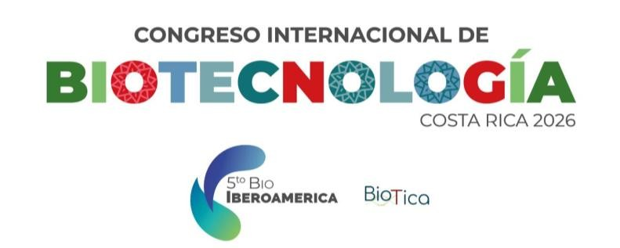

Oral Presentation Guidelines
Oral presentations aim to communicate scientific advances clearly and concisely, promoting discussion and interaction among participants.
General Requirements
- Language: English or Spanish.
- Format: PowerPoint (.pptx) or PDF (download the official template in the Congress website).
- Aspect ratio: 16:9.
- Presentation + Q&A: 15 minutes.
Content Requirements
- Title slide.
- Mandatory conflict of interest disclosure slide.
- Objectives.
- Methods.
- Results-Discussion.
- Concluding remarks.
Recommendations
- Suggested number of slides: 10-15.
- Use clear figures and minimal text.
- Avoid excessive branding or commercial content.
- Results must correspond to the submitted abstract.
Submission
- Authors of accepted oral presentations must send the final PowerPoint (.pptx) or PDF version of their presentation no later than September 30th, 2026.



